Pore network model of electrokinetic transport
through charged porous media

A. Obliger^{1,2,3}, M. Jardat,^{1,2}, D. Coelho³, S. Bekri⁴, B. Rotenberg^{1,2}.
¹ Sorbonne Universités, UPMC Univ. Paris 06, UMR 8234 PHENIX, Paris, France
² CNRS, UMR 8234 PHENIX, Paris, France
³ Andra, Châtenay-Malabry, France
⁴ IFP Energies nouvelles, Rueil-Malmaison, France
E-mail: amael.obliger@upmc.fr

We introduce a method for the numerical determination of the steady-state response of complex charged porous media to pressure, salt concentration and electric potential gradients. The macroscopic fluxes of solvent, salt and charge are computed within the framework of a Pore Network Model (PNM) [1], which describes the pore structure of the samples as networks of pores connected to each other by channels. The PNM approach is used to capture the couplings between solvent and ionic flows which arise from the charge of the solid surfaces. The microscopic transport coefficients on the channel scale, taken here of a simple analytical form obtained previously by solving the Poisson-Nernst-Planck and Stokes equations in a cylindrical channel [2], are upscaled for a given network by imposing conservation laws for each pores, when macroscopic gradients are applied to the sample. The complex pore structure of the material is captured by the distribution of channel diameters. We investigate the combined effects of this complex geometry, the surface charge and the salt concentration on the macroscopic transport coefficients. The upscaled numerical model preserves the Onsager relations between the latter, as expected [3]. The calculated macroscopic coefficients behave qualitatively like their microscopic counterparts, except for the permeability (see Fig. 1) and the electro-osmotic coupling coefficient when the electrokinetic effects are strong. Quantitatively, the electrokinetic couplings increase the difference between the macroscopic coefficients and the microscopic ones for a single channel of average diameter.
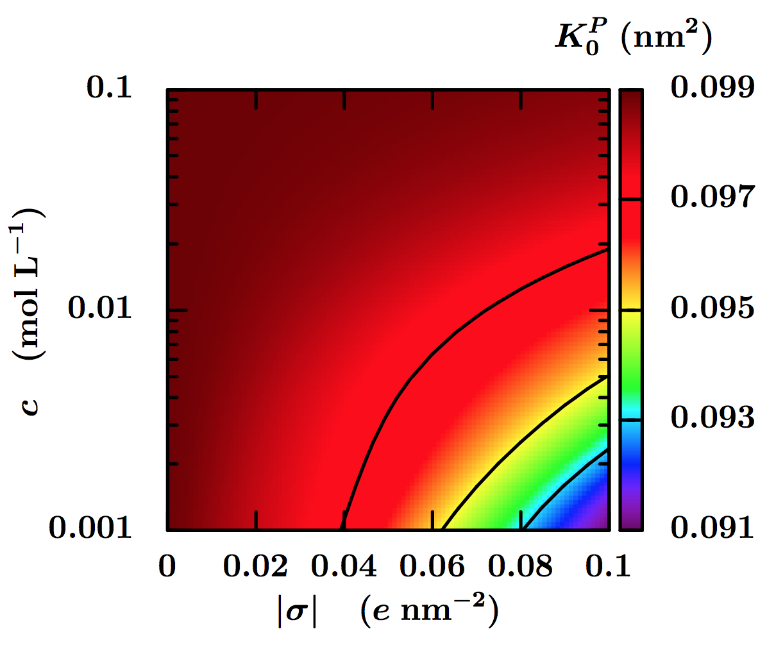
Fig. 1 Macroscopic permeability K₀^{P} (in nm²) as a function of the salt concentration c in the reservoirs in equilibrium with the charged porous material, and of the surface charge density σ of the channels.

References
1. S. Békri, C. Laroche, O. Vizika. International Symposium of the Society of Core Analysts, 2005.
2. A. Obliger, M. Duvail, M. Jardat, D. Coelho, S. Békri, and B. Rotenberg, Physical Review E 88, 013019 2013.
3. E. Brunet and A. Ajdari, Physical Review E 69, 016306 2004.

